840/2
Computer Studies
PAPER 2
July/August 2022
2 Hours

BUGANDA EXAMINATIONS COUNCIL MOCKS

Uganda Certificate of Education

Computer Studies

2 Hours

INSTRUCTIONS TO CANDIDATES:

The paper consists of two sections; A and B. Section A contains One Compulsory question.
Section B contains three questions. Answer any two questions from this section. Any additional questions will not be marked.
Each candidate is provided with a new blank Compact Disk (CD). Candidates should continuously save their work.
Each candidate should produce a hard copy of the each of their work to accompany the
Compact Disk.
Create a folder on the desktop in your name and personal number in which to save all your work.
SECTION A: (40 MARKS)

- (a) Use a word processor of your choice, produce the document below as it appears. (06 marks)
ICT AS A TOOL FOR TEACHING AND LEARNING

The term ICT is stands for Information and Communication Technology and is defined as a “Diverse set of technological tools and resources used to communicate, and to create, disseminate, store, and manage information”. ICT has become a very important part of the educational delivery and management processes. ICT largely facilitated the acquisition and absorption of knowledge and hence providing extraordinary opportunities to developing countries for enhancing their educational systems particularly for the under privileged constituency, and thereby raising the level of quality of life for their people.

(b) Copy the document to another page (01 mark)
(c) Double space the text in the copy document. (01 mark)
(d) Italicize and bold the word ICT throughout the document. (01 mark)
(e) Use “Times New Roman” font face and font size, “12” for the entire document. (01 mark)
(f) Insert your name and personal number as footer and header respectively. Centre align them. (03 marks)
(g) Use mail merge feature to post the document above to the recipients below and save the letters as merged letter (05 marks)
NAME | ADDRESS | COUNTRY
MS AKIIRO GRACE | P.O BOX 23 KAMPALA | UGANDA
MR.ASSIMWE ANDREW | P.O BOX 19 NAIROBI | KENYA

(h) Save your work as your name and personal number. (01 mark)
(i) Print all your work. (01 mark)
(b) A school produced an end of term one mark list for senior five; using any spreadsheet program enter the data in the table below. (04 marks)
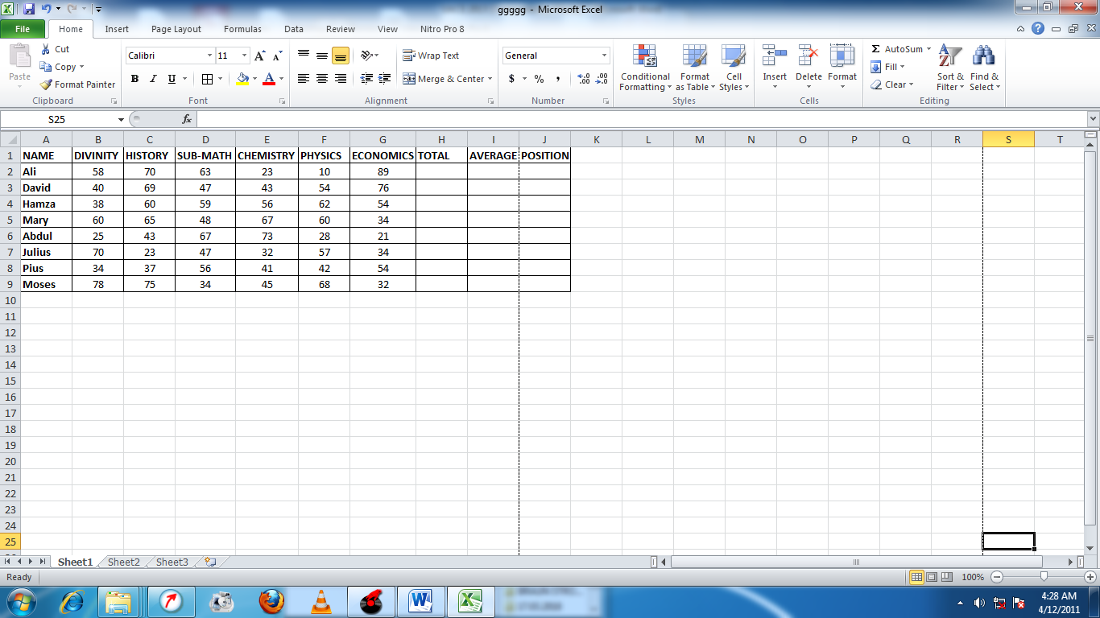
(b) Provide a heading for your worksheet as “KKL Secondary School, Results for 2020” and center it with font size 21. (03 marks)
(c) Using appropriate functions determine for each student the
(i) Total mark. (01 mark)
(ii) Average mark. (01 mark)
(iii) Position. (02 marks)
(d) Apply boarders on the data you have entered in the worksheet. (01 mark)
(e) Insert your name and personal number as footer. (01 mark)
(f) The sheet for the table should be named as Table. (01 mark)
(g) Create a pie chart using the average marks, and include:
(i) The Heading “Senior Five term one marks, KKL Secondary School”
(01 mark)
(ii) Insert labels on the chart. (01 mark)
(h) Copy the chart to sheet 2 and name it Chart. (02 marks)
(i) Save your work as your name and personal number. (01 mark)
(j) Print your work. (01 mark)
SECTION B: (60MARKS)
ANSWER ANY TWO QUESTIONS FROM THIS SECTION

- Use any desktop publishing software to design a certificate of excellence for KKL Senior Secondary Senior four (S.4) candidates who have excelled in the following application packages: Ms Word, Ms Excel, Ms PowerPoint, Ms Access and Ms Publisher. Provide space for signatures of the head teacher and head of ICT department. (10 marks)
- Adjust the paper size to a width of 11 inches and height of 8.5 inches.
(02 marks)
- Insert clip art to represent the owners photograph. (02 marks)
- Use your name as the owner of the certificate. (02 marks)
- Use your name and personal number in the footer. (02 marks)
- Save the work as your name and print your publication. (02 marks)
- In a learner centred approach, a teacher uses some learners to pass on knowledge to their fellow learners. It makes learning fun as learners get to learn from one another. Senior four (S.4) learners can pass on knowledge to senior two (S.2) learners and vice versa.
Study the information and perform the tasks below.
Categories of Computer Devices
Computer devices are sub divided into four categories as follows:
- Input devices
- Output devices
- Processing devices
- Storage devices
Input devices:-These are any hardware components used to enter data and instructions into a computer system. E.g. .Keyboard
Output devices: - These are any hardware components used to display or convey information or data to a user. E.g. monitor
Processing devices: - This is used to manipulate data into information. Processing is usually done in the Central Processing Unit (CPU).

Storage devices: - These are used to record and retrieve data to and from a storage medium in the computer system. They can be either internal like the HDD, or external like a CD. Storage devices have got their specialized drives through which data can be written or read. For example, data on a CD can be read with the help of a CD or DVD drive.
Conclusion:
Whereas the above devices are standard input-output devices, some other devices are referred to as computer peripherals. Computer peripherals are any electronic devices that can be hooked to a computer. Examples of peripherals include speakers, microphone, printers, scanners and digital cameras.
Tasks
- As a senior four Computer Studies student prepare a four slide presentation for the S.2 learners summarizing the information given above.
(08 marks)
- Save the presentation with your name. (01 mark)
- Insert a footer as your name and personal number. (01 mark)
- Change the background of all slide titles to an appropriate style.
(01 mark)
- Set the slide transition of your choice, with transition time of 6 seconds.
(02 marks)
- Set animations of your choice for all slide titles and other parts of the slides. (01 mark)
- Make use of speaker’s notes and relevant graphics. (02 marks)
- Insert a summary tabular slide between the last slide and second last slide with the following data. (03 marks)
Summary table:
NO | DEVICE | HARDWARE CATEGORY
1 | Keyboard &Mouse | Standard Input device
2 | Monitor | Output device
3 | CPU | Processing device
4 | Hard Disk | Storage
5 | Speakers, Microphones, printers, scanners, and digital cameras | peripherals
- Save as your name personal number and print your work to fit on one page. (01 mark)
- The table below shows medical records of a certain clinic
PID | Fname | District | DoB | Diagnosis | Treatment fee
P02 | Omondi | Busia | 3/2/1996 | Malaria | 10000
P04 | Katiba | Kampala | 6/9/1997 | Typhoid | 100000
P05 | Waiswa | Busia | 3/5/1981 | Tuberculosis | 20000
P06 | Nambi | Busia | 2/8/1989 | Dysentery | 120000
P09 | Lumu | Kampala | 4/5/1990 | Malaria | 30000
P11 | Nafula | Busia | 5/11/1989 | Tuberculosis | 20000
P15 | Waiswa | Jinja | 10/11/1978 | Malaria | 60000

- Create a database called JMS Medical Details. (01 mark)
- Design a table with appropriate data types in design view called Patients. (04 marks)
- Design a form called Patient form and use it to enter the given data in the table. (04 marks)
- Create a query to display all the details of patients who come from either Jinja or Busia. Save it as Eastern Patients. (02 marks)
- Create a query to display all the details who were not diagnosed with Tuberculosis. Save it as Non Critical. (02 marks)
- If the Government pays 40% of treatment fee for all patients, create a query to calculate discounted fee. Put only F name, DoB, Diagnosis and Treatment Fee on the display. Save it as Reduced fee. (03 marks)
- Create a report to display the information in the discounted fee query.
(03 marks)
- Print your work. (01 mark)

END

